།བློ་འཕེལ་གླིང་གཏན་འཇགས་སློབ་གྲྭ་།
>L Nff]km]nlnË af]l8{Ë :s"n, dgfË
Lophelling Boarding School
Manang Nyeshang Rural Municipality – 5 Brakka, Manang

SCHOOL REPORT
(25th March 2022 to 15th July 2022)

Before I start to jot down my report, firstly I want to pay my warm Tashi Deleck / Namaste to you all.
It is pleasure to write down the activities that we did within this 4 months (15th March to 15th July 2022). Generally, all the activities related with academic and co-curricular activities are jot down in my School Diary. We prepared this diary by arranging with Nepal Government’s Education policy. We did all activities as school diary till upto July 15th.
Because of bridge repairment work between Manang and besisahar, the road was blocked for 2 weeks. That’s why we the staffs climbed direct up to Danaque on 21st of March,Monday.
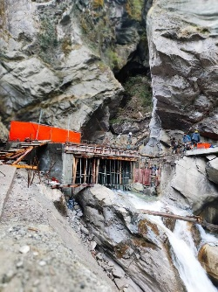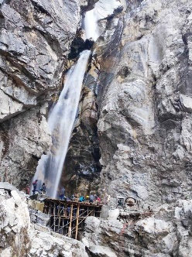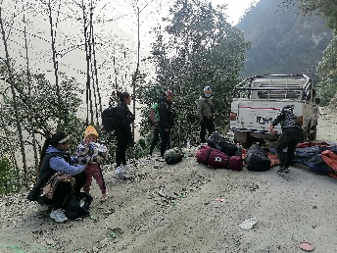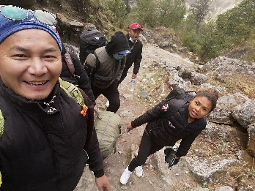
On 22nd March, Tuesday: we all reached safely at school. Cleanliness program started. All the bedding are taken sunbathe. And all the rooms are cleaned so that students would be assemble tomorrow.
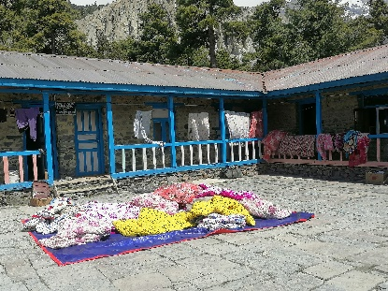

On 23rd March Wednesday: There was a staff meeting in the morning. We discussed how to run the school smoothly without any obstacle. In the afternoon, all students gathered. School administration distributed Masks and sanitizer to all LBS family for safety precaution.
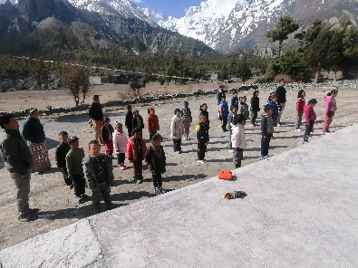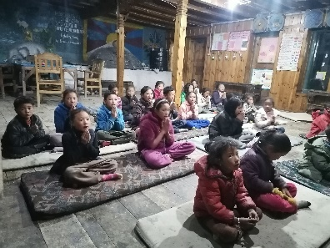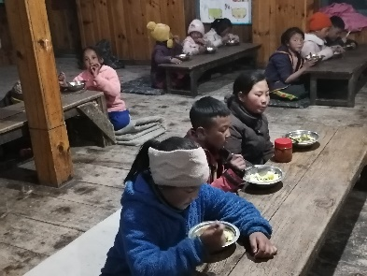
Students assemble on first day Evening Prayer Taking Meals

On 25th March 2022, Friday : Staff meeting was held. The meeting was focused on Annual School activities and diary.
On 10th April 2022, Sunday : All my students got vaccine for Pfizer. These vaccine also increase the immunity and protect from corona virus. Mr. Kancha Ghale, chairman of Nyeshang Rural Municipality also inspected on that day.
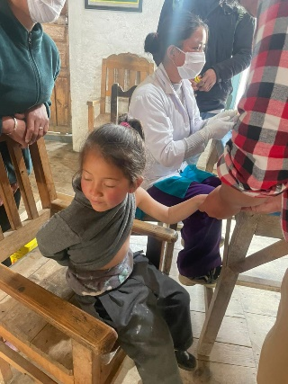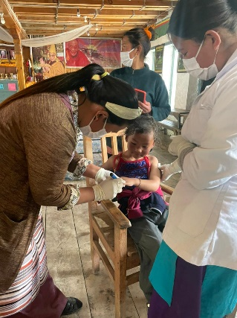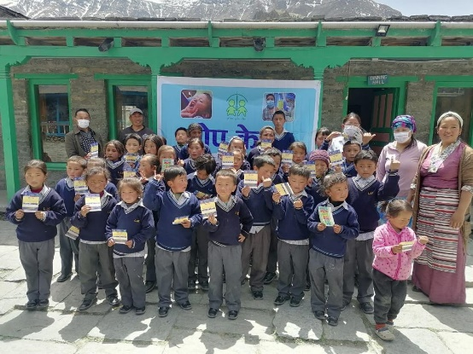
While taking vaccine Group photo with Chairman and health workers
On 2nd May 2022, Monday : Mr. Palden Wangchuk (Cook) and foster Mama Mrs. Dechen Gurung have resigned their job. So small pizza party was organized for them to pay Thanks. New cook Mr. Buchhima Lama and new mama Mrs. Pasang Sherpa are appointed.
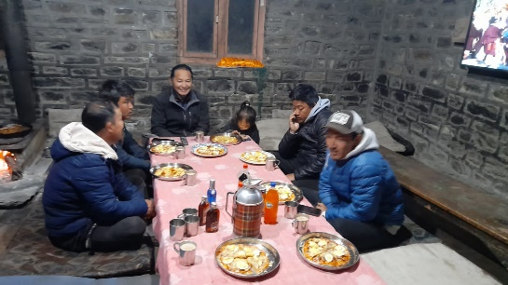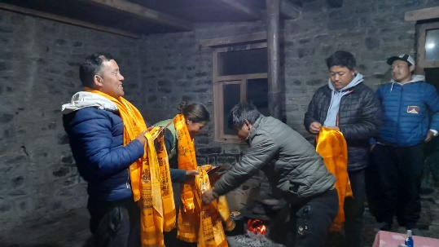
From 29th April 2022, Friday : Annual Examination of the session 2021/2022 was started. All the teachers and the students were focusing on studies.
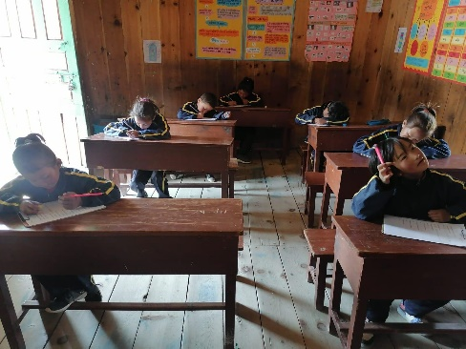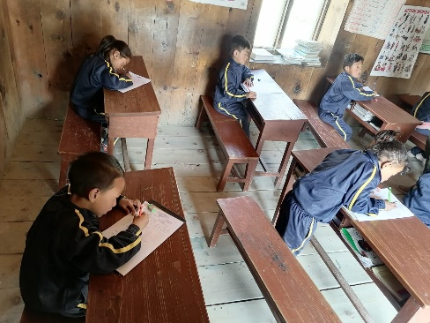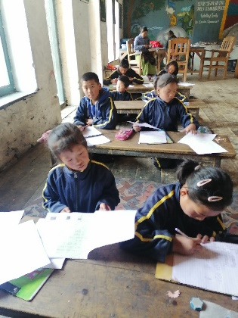
On 8th May 2022, Sunday : Annual Prizes distribution was done. Most of the students got prizes in different activities. Best calligraphers and Best Readers in three languages, best artist, best painter, school’s leaders and captain, talented students got many prizes.
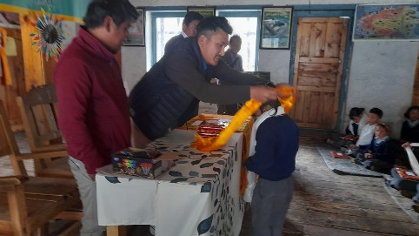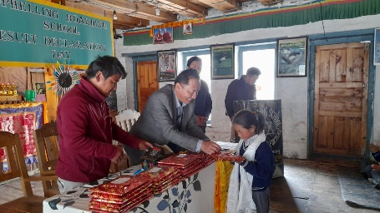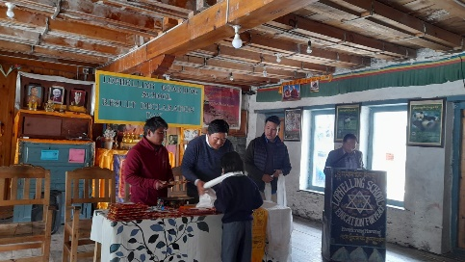
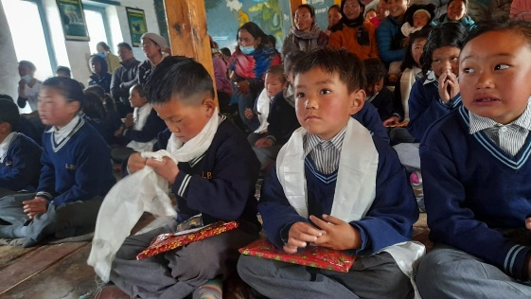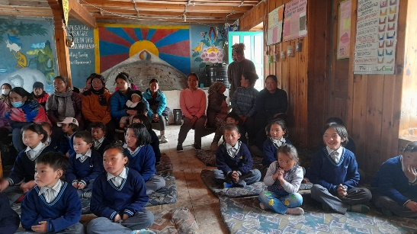

On 8th May 2022,Sunday : Small tea party was organized to outgoing students. These year 7 students had joined Mt. Kailash School by completing LBS.
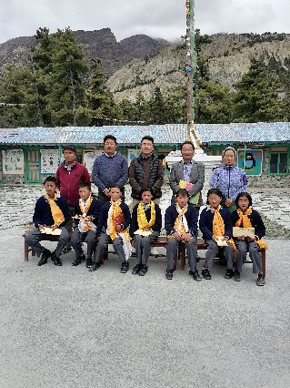 7 out going students with teaching staffs.

On 9th May 2022, Monday : New admission 2022/2023 was started. 21 new students were admitted at school. All staff were trying to create excellent environment to newly students.
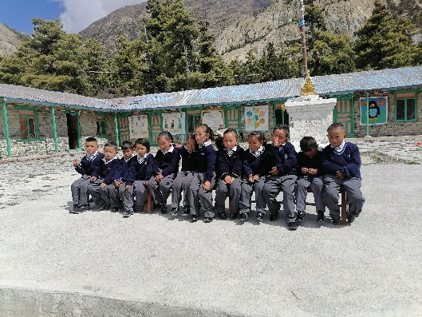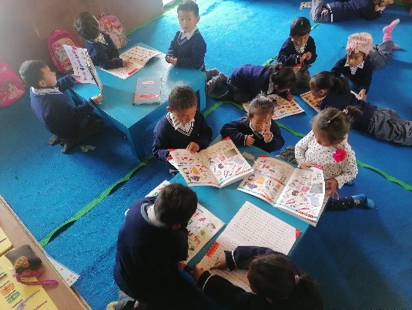

On 11th May 2022, Tuesday : Mr. Johannes Eisner was reached school to guide the roof renovation. As we got many trouble during rainy season, Nepal Initiative Schongau started to put new roof to the dining hall.
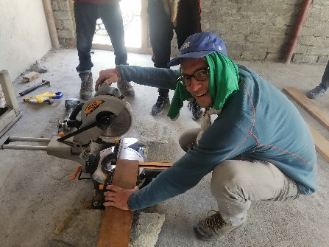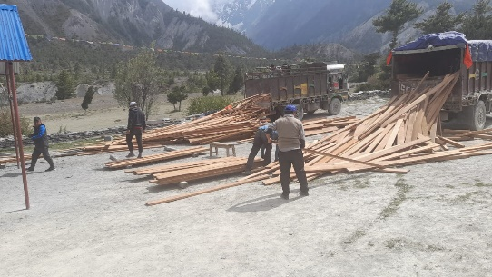

On 16th May 2022, Monday : All the staffs with students went to Kyung village to get blessing from Kyung monastery. Buddha birthday was fell on this day.
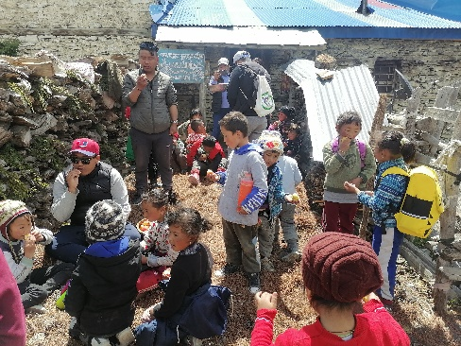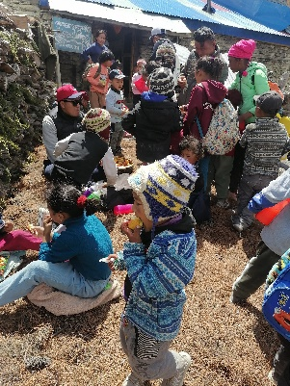

On 8th June 2022, Wednesday : Mr. Geggi from Germany came here for roof renovation. We put new sheets to the washing place.
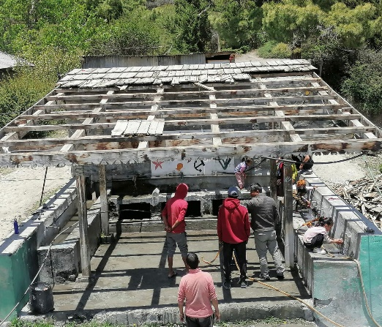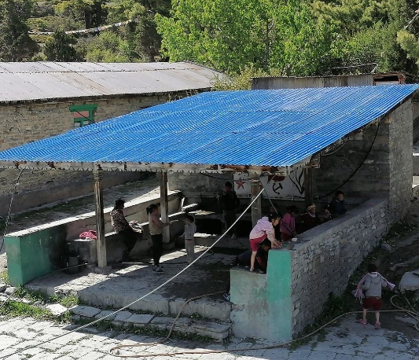

On 24th June 2022, Friday : we have finished our roof renovation. Now we have no tension from rain.
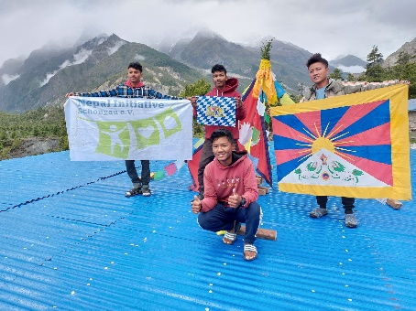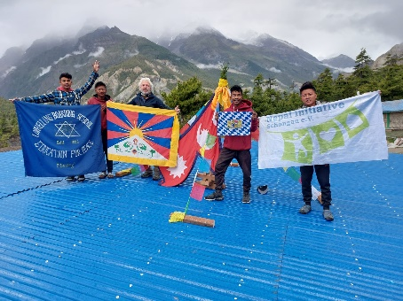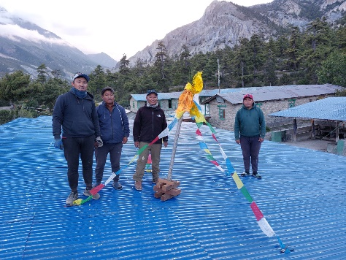
Four active boys from Rangeen Home with Mr. Geggi Teaching Staffs of LBS
On 25th June 2022, Saturday : Mr. Geggi with 4 active students went down to kathamndu by completing roof renovation.
On 6th July 2022, Wednesday : 6th July 2022 is the 87th Birthday of His Holiness The Dalai Lama. The function was organized at school. Almost 600 people gathered to celebrate his 87th birthday. LBS family presented three cultures to the public.
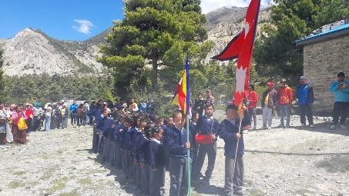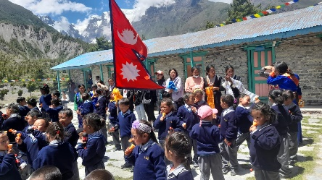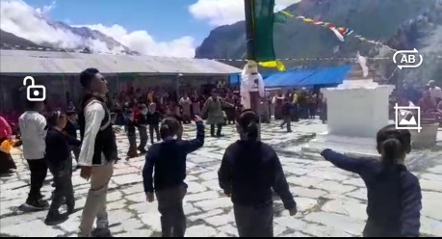
On 7th July 2022, Thursday : There was a puja at dining hall for long live of H.H. The Dalai Lama and the world peace.
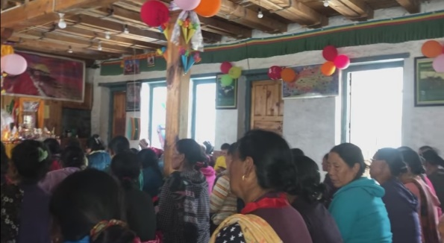

From 7th July 2022, Thursday to 12th July, Tuesday : The school was closed for 6 days as students did not get outing last three months.
On 13th July 2022, Wednesday : All students will gather at school for their regular class as before.
Last but not the least, I would like pay my THANKS to Nepal Initiative Schongau e.V. and all the concern sponsors. Without your supports, this school can’t run smoothly. Thanks to Snow Lion Foundation. Without your guidance and supports, this school would not be in Manang.
Lastly, Because of roof renovation, I was busy with that work so that there are some activities which we postponed. Hope everything goes smoothly as school diary in next days.

Thanking You
Gonpo Wangchuk
Headmaster,
Lophelling Boarding School,
Manang Nyishang Rural Municipality,
Ward – 5, Brakka, Manang District,
Gandaki Zone,
Nepal

